Monday  January 25  Shine Bright with Kindness  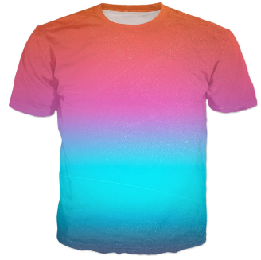  Wear Bright Clothes | Tuesday  January 26  Dreaming of Kindness  Wear PJ’s | Wednesday  January 27  Powered by Kindness  Dress like a Superhero or in a Superhero shirt. | Thursday  January 28  Spread Kindness Like Sunshine  Wear Yellow | Friday  January 29  Never Too Old for Kindness  Dress up like an old person or in your Snyder Shirt

